**Summary of Chapter 3**

**Business Ownership Decisions**

This looks at the type of business that the individual intends to open or startup.

It may depend on how big of a business you intend to start up.

**Common Terms**

1. **Capital**

Starting point for the business which can be described as the pumping in of monetary value or any valuable assets for the business

1. **Liabilities**

Owings or expenses which incurs in the business which is a negative aspect as this involves the outflow of cash.

It can be something that depreciates in value in the long term run.

1. **Assets**

This is described as valuable items which generates income or appreciates in value. Example of this are properties, gold and others.

1. **Profits**

This looks at the extra residual that is left upon clearing all expenses and capital. This extra income is considered as a profit.

**Common forms of business ownerships**

* **Sole Proprietorship**
  + Owned by a single owner.
  + All decisions are done by a single person
  + Any profits belong solely to the individual who doesn’t need to share it with other individuals
  + All liabilities and losses are borne by the individual alone.
* **Partnership**

**General Partnership**

* A general partnership is **a business arrangement by which two or more individuals agree to share in all assets, profits, and financial and legal liabilities of a jointly-owned business**. In a general partnership, **partners agree to unlimited liability, meaning liabilities are not capped and can be paid through the seizure of an owner's assets.** Furthermore, any partner may be sued for the business's debts.
* **Each is responsible for their personal tax liabilities—including partnership earnings—on their income tax returns as taxes do not flow through the general partnership**.

A general partnership must satisfy the following conditions:

* The partnership must minimally include two people.
* All partners must agree to any liability that their partnership may incur.
* The partnership should ideally be memorialized in a formal written partnership agreement, though oral agreements are valid.

**Limited Partnership**

* A limited partnership exists when **two or more partners** go into business together, but **one or more of the partners are only liable up to the amount of their investment**.

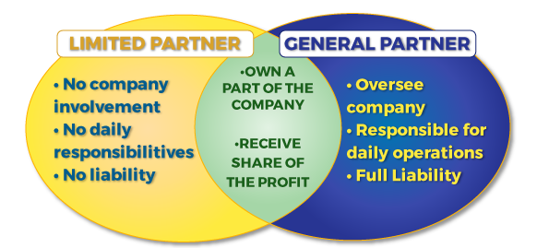

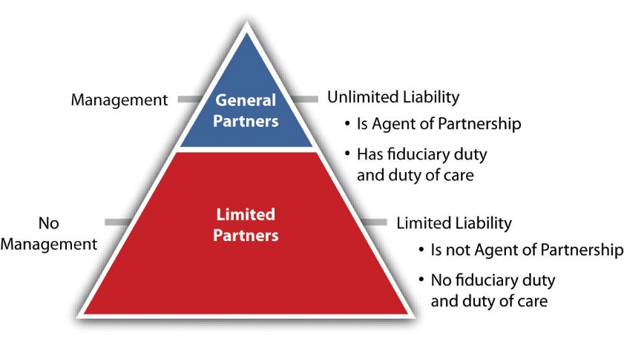

**Differences between General partnership and limited partnership**

|  |  |
| --- | --- |
| General | Limited |
| A general partnership is the most common type of partnership. It refers to a relationship in which all partners contribute to the day-to-day management of the business. Each partner will have the authority to make business decisions and even legally bind the company in contracts.  The liabilities, contributions, and responsibilities of the partners are often equal unless stated otherwise. Typically, a partnership agreement will describe which partners have certain authorities and responsibilities. | A limited partnership is a relationship where one or more partners are not involved in the day-to-day management of the business. Often, a limited partner, sometimes known as a “silent partner,” will serve solely as an investor in the business, with the funds that they contribute being the extent of their liability. However, since the limited partner does not have decision-making power in the company, withdrawing funds – even just the amount they’ve already contributed – cannot be done without the approval of a general partner.  Limited partnerships will still have at least one general partner to man the day-to-day operations of the business. A general partner may invest money into the company. However, a general partner may also be personally liable for the debts of the company, while the limited partner is not. Only a general partner’s personal assets (in addition to the business assets) can come into play when it comes to paying off the company’s debts.  limited partnerships are an extremely popular choice for private equity firms, which purchase privately-owned companies in the hopes of increasing their value. Often, the private equity company’s name is not particularly well-known compared to the companies it invests in. For example, the Roark Capital Group is a large private equity firm and limited partnership that has invested in companies such as Arby’s, Jamba Juice, Sonic, Maaco and Meineke. |

* **Corporation**
  + A corporation is a **legal entity** that is separate and distinct from its owners.
  + Corporations enjoy most of the **rights and responsibilities** that individuals possess which includes **they can enter contracts, loan and borrow money, sue and be sued, hire employees, own assets, and pay taxes.**
  + Some refer to it as a **"legal person."**
* **Small Corporation**
  + Firm has 75 or fewer employees.
  + Owners have limited liability, but are taxed as if the firm were a partnership.
* **Limited Liability Corporation (LLC)**
  + A **Limited Liability Corporation (LLC)** is a business structure in the United States whereby the **owners are not personally liable for the company's debts or liabilities.** Limited liability companies are hybrid entities that **combine the characteristics of a corporation with those of a partnership or sole proprietorship.**
* **Joint venture**
* A joint venture is an agreement between two or more parties to contribute a part of their resources (assets and/or expertise) to a specific project.
* **Private Companies**
* This type of company is a separate legal entity from its owners, which means this company is considered as a legal 'person' that can buy or sell property, present into legal contracts, sue or get sued in courts of law.
* **Public Companies**
* A public company is a corporation whose ownership is distributed amongst general public shareholders via the free trade of shares of stock on exchanges or over-the-counter markets.

**Differences between Public and Private**

A private company is a closely held one and requires at least two or more persons, for its formation. On the other hand, a public company is owned and traded publicly. It requires 7 or more persons for its set up.